Aggregation and Grouping

1️⃣ Count the Number of Movies Per Year (Descending Order)
(Identify the most prolific years for movie releases)

db.movies.aggregate([
{ $group: { _id: "$year", count: { $sum: 1 } } },
{ $sort: { count: -1 } }
])







2️⃣ Find the Average IMDB Rating by Genre
(Analyze how different genres are rated on average)

db.movies.aggregate([
{ $unwind: "$genres" },
{ $group: { _id: "$genres", avgRating: { $avg: "$imdb.rating" } } },
{ $sort: { avgRating: -1 } }
])









3️⃣ Count Movies by Director and Sort by Count
(Find the most prolific directors)

db.movies.aggregate([
{ $unwind: "$directors" },
{ $group: { _id: "$directors", movieCount: { $sum: 1 } } },
{ $sort: { movieCount: -1 } },
{ $limit: 10 }
])





4️⃣ Calculate the Average Number of Cast Members per Movie by Year
(Track how cast sizes have evolved over time)

db.movies.aggregate([
{ $project: { year: 1, castSize: { $size: { $ifNull: ["$cast", []] } } } },
{ $group: { _id: "$year", avgCastSize: { $avg: "$castSize" } } },
{ $sort: { _id: -1 } }
])




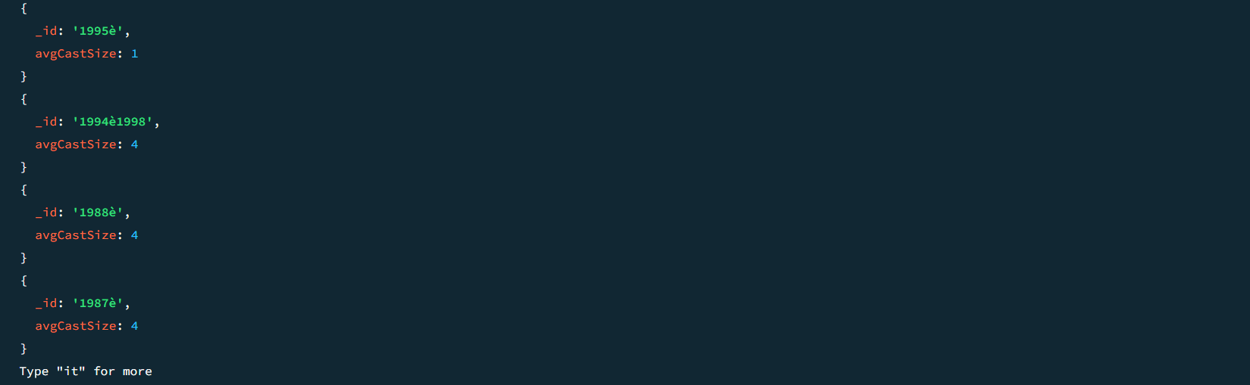

5️⃣ Find the Highest Rated Movie Per Director
(Discover a director's top-rated film)

db.movies.aggregate([
{ $unwind: "$directors" },
{ $sort: { "imdb.rating": -1 } },
{ $group: { _id: "$directors", topMovie: { $first: "$title" }, rating: { $first: "$imdb.rating" } } },
{ $sort: { rating: -1 } }
])

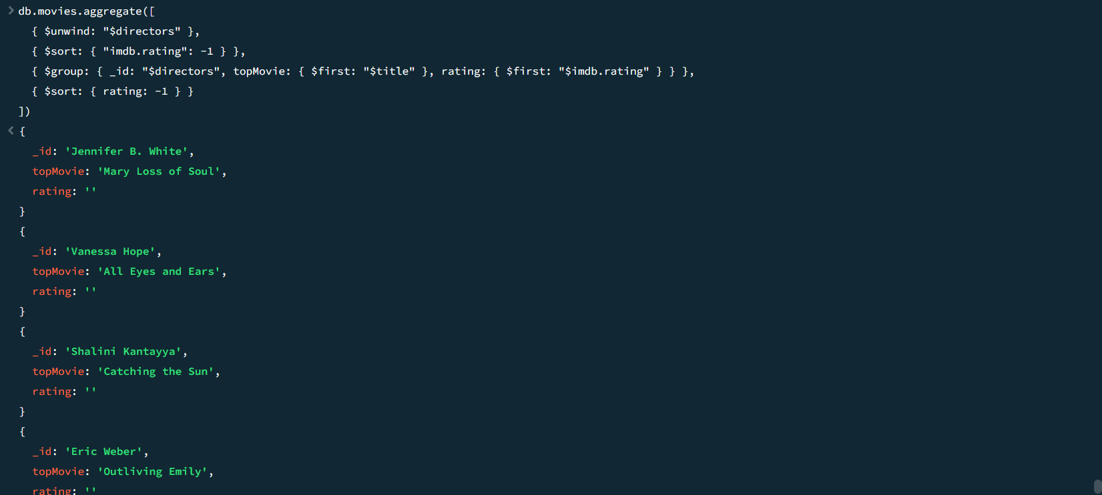






6️⃣ Count the Number of Movies by Rating Category
(Evaluate how many movies fall into different rating categories)

db.movies.aggregate([
{ $group: { _id: "$rated", count: { $sum: 1 } } },
{ $sort: { count: -1 } }
])







7️⃣ Calculate the Average IMDB Rating by Release Year (Last 30 Years)
(Analyze how ratings have trended over recent decades)

db.movies.aggregate([
{ $match: { year: { $gte: 1994 } } },
{ $group: { _id: "$year", avgRating: { $avg: "$imdb.rating" } } },
{ $sort: { _id: 1 } }
])







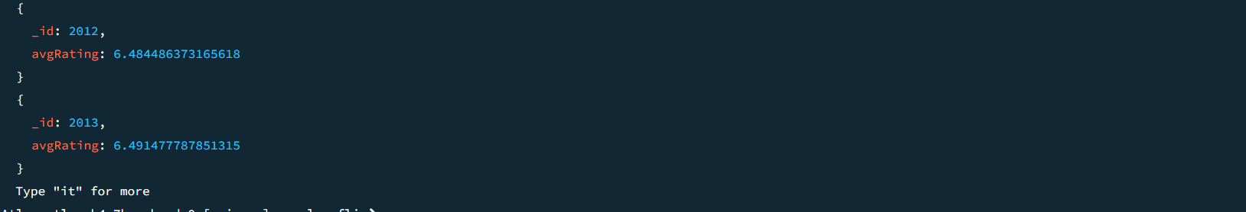

8️⃣ Find Popular Actors Based on Number of Appearances
(Identify the most frequently cast actors)

db.movies.aggregate([
{ $unwind: "$cast" },
{ $group: { _id: "$cast", appearances: { $sum: 1 } } },
{ $sort: { appearances: -1 } },
{ $limit: 10 }
])





9️⃣ Group Movies by Language and Find the Average IMDB Rating
(Compare the performance of different languages in cinema)

db.movies.aggregate([
{ $unwind: "$languages" },
{ $group: { _id: "$languages", avgRating: { $avg: "$imdb.rating" }, count: { $sum: 1 } } },
{ $match: { count: { $gt: 5 } } }, // Only consider languages with more than 5 movies
{ $sort: { avgRating: -1 } }
])











🔟 Calculate the Average Runtime by Genre
(See which genres tend to have longer runtimes)

db.movies.aggregate([
{ $unwind: "$genres" },
{ $group: { _id: "$genres", avgRuntime: { $avg: "$runtime" } } },
{ $sort: { avgRuntime: -1 } }
])







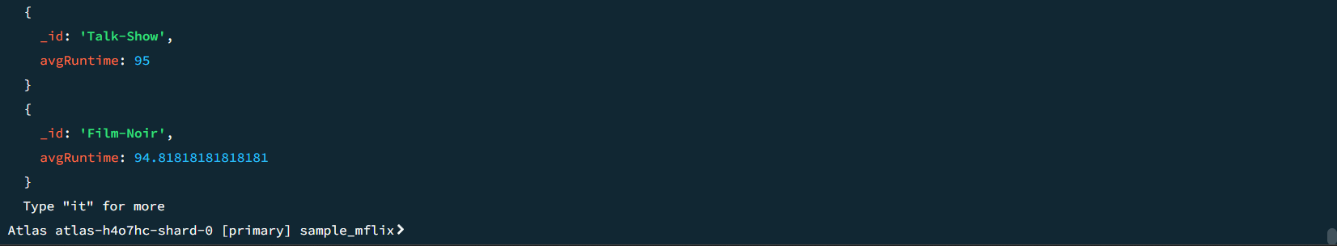

1️⃣1️⃣ Calculate the Correlation Between IMDB Rating and Number of Awards
(Understand the relationship between critical acclaim and audience ratings)

db.movies.aggregate([
{ $match: { "imdb.rating": { $exists: true }, "awards.wins": { $exists: true } } },
{ $group: {
_id: null,
avgRating: { $avg: "$imdb.rating" },
avgAwards: { $avg: "$awards.wins" },
ratingStdDev: { $stdDevPop: "$imdb.rating" },
awardsStdDev: { $stdDevPop: "$awards.wins" },
covariance: {
$avg: {
$multiply: [
{ $subtract: ["$imdb.rating", { $avg: "$imdb.rating" }] },
{ $subtract: ["$awards.wins", { $avg: "$awards.wins" }] }
]
}
}
}
},
{ $project: {
_id: 0,
correlation: {
$divide: [
"$covariance",
{ $multiply: ["$ratingStdDev", "$awardsStdDev"] }
]
}
}
}
])

